Gemini Pro Financial Decoder: Transforming Complex Data into Actionable Insights

INTRODUCTION
Project Name : Gemini Pro Financial Decoder: Transforming Complex Data into Actionable Insights
Team Members and Roles:
- Kuruva Pakkirappa Gari Swetha - Team Leader / Project Manager

- Patan Arshiya - Frontend & UI Developer

- Kille Naresh - Backend & API Developer

- Shaik Suhail - AI & Data Analyst

PROJECT OVERVIEW
The Gemini Pro Financial Decoder is an AI-powered web application designed to simplify the analysis of complex financial data and transform it into clear, actionable insights. In today’s data-driven financial environment, businesses and individuals generate large volumes of financial documents such as balance sheets, income statements, cash flow reports, and spreadsheets. Interpreting these documents manually requires significant time, expertise, and effort.
This project leverages the capabilities of Gemini Pro, a generative AI model, to automatically analyze financial documents and extract meaningful information. The system allows users to upload financial files in formats such as PDF, Excel, or CSV. After preprocessing and structuring the data, the AI engine generates summaries, identifies key financial metrics, detects trends and risks, and presents the results through interactive dashboards and downloadable reports.
The application is designed with a user-friendly interface, secure authentication, and scalable architecture to support multiple users and large datasets. By combining web technologies, data processing tools, and AI-driven analysis, the Gemini Pro Financial Decoder aims to reduce manual effort, enhance accuracy, and improve financial decision-making.

ARCHITECTURE

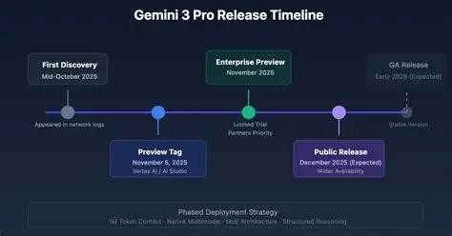

The architecture of the Gemini Pro Financial Decoder follows a modular and layered design to ensure scalability, security, and efficient data processing. The system is divided into multiple interconnected layers, each responsible for specific functionalities.

Presentation Layer (Frontend)
The frontend layer provides the user interface where users can:
  - Log in securely
  - Upload financial documents (PDF, Excel, CSV)
  - Ask queries in natural language
  - View generated insights, charts, and reports
This layer ensures smooth user interaction and visual representation of financial analysis results.

Application Layer (Backend API)
The backend layer handles:
  - Processing user requests
  - Managing document uploads
  - Authentication and authorization
  - Communication between frontend and AI engine
It ensures secure workflow management and data handling.

Data Processing Layer
Once documents are uploaded, this layer:

  - Cleans and structures financial data
  - Extracts relevant numerical and textual information
  - Converts raw data into a format suitable for AI analysis
This step improves accuracy and consistency before sending data to the AI model.

AI Intelligence Layer
This is the core component of the system. The Gemini Pro model:
  - Analyzes financial data
  - Extracts key metrics
  - Identifies trends and anomalies
  - Generates summaries and actionable insights
This layer transforms complex financial information into understandable explanations.

Data Storage Layer
The database layer securely stores:
  - Uploaded documents
  - Processed data
  - Generated insights
  - User logs and activity
It ensures data integrity and future retrieval.

Security Layer
Security mechanisms are applied across all layers, including:
  - User authentication (JWT / OAuth2)
  - Encrypted communication (HTTPS / SSL)
  - Secure data storage

SETUP INSTRACTIONS

System Requirements
Before installation, ensure the following are available:
    - Python 3.9 or above

    - Node.js (if frontend is used separately)
    - Internet connection (for Gemini Pro API access)
    - Code Editor (VS Code recommended)
    - Git (optional)

Clone the Repository
git clone <repository-link> cd gemini-financial-decoder

Create Virtual Environment
python -m venv .venv
Windows:
.venv\Scripts\activate

Install Required Dependencies
pip install -r requirements.txt
  - Configure Gemini Pro API Key
- Create a .env file in the project folder.
- Add your Gemini API key:
GOOGLE_API_KEY=your_api_key_here

  - Run the Backend Server

  - Access the Application

  - Testing the Setup

python app.py

http://localhost:8000

    - Upload a sample financial document (Excel/PDF)
    - Verify that insights and summaries are generated
    - Check logs for any errors

FOLDER STRUCTURE
The project follows a modular folder structure to ensure proper organization, scalability, and easy maintenance. Each folder is responsible for a specific functionality within the system.

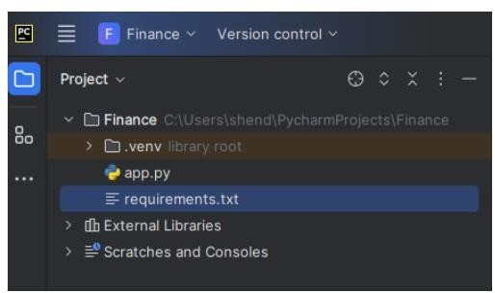

- frontend/ – Contains user interface components and dashboard implementation.
- backend/ – Manages APIs, authentication, and request handling.
- ai_engine/ – Handles Gemini Pro integration, prompt engineering, and financial insight generation.
- data/ – Stores uploaded documents and generated reports.
- database/ – Contains database connection and schema configuration.
- .env – Stores sensitive credentials such as API keys.

RUNNING THE APPLICATION
app.py
import streamlit as st import pandas as pd import numpy as np import os
import google.generativeai as genai

#
# PAGE CONFIG (MUST BE FIRST) #
st.set_page_config(page_title="Gemini Pro Financial Decoder")

#
# APP TITLE (THIS WAS MISSING) #

s t . ti tl e( " xGemini Pro Financial Decoder")
st.write("Upload CSV files to generate AI-powered financial insights.")

#
# API KEY (CORRECT WAY) #
API_KEY = os.getenv("GOOGLE_API_KEY")

if not API_KEY:
st.error("+ GOOGLE_API_KEY not set") st.stop()

genai.configure(api_key=API_KEY)
model = genai.GenerativeModel("gemini-pro")

#
# FILE UPLOAD #
st.subheader("çv.† Upload Financial Files")

balance_file = st.file_uploader("Balance Sheet CSV", type="csv") pl_file = st.file_uploader("Profit & Loss CSV", type="csv") cash_file = st.file_uploader("Cash Flow CSV", type="csv")

#
# FUNCTIONS #
def load_csv(file): if file:
return pd.read_csv(file) return None

def generate_summary(df, name): if df is None:
return "⚠ No file uploaded"

prompt = f"""
Analyze this {name} data and give:
- Key insights
- Strengths
- Weaknesses

Data:
{df.head(5)} """
response = model.generate_content(prompt) return response.text

def visualize(df, title): if df is None:
return

st.subheader(title) st.dataframe(df)

num = df.select_dtypes(include=np.number) if not num.empty:
st.line_chart(num)

#
# BUTTON (THIS EXECUTES UI) #
if st.button("7s•¸.˙' Generate Report"): with st.spinner("Analyzing..."):

balance_df = load_csv(balance_file) pl_df = load_csv(pl_file)
cash_df = load_csv(cash_file)

st.success("⬛Analysis Complete")

st.markdown("## ]_H Balance Sheet") st.write(generate_summary(balance_df, "Balance Sheet")) visualize(balance_df, "Balance Sheet Data")

st.markdown("## ]_H Profit & Loss")
st.write(generate_summary(pl_df, "Profit & Loss")) visualize(pl_df, "Profit & Loss Data")
st.markdown("## ]_H Cash Flow")
st.write(generate_summary(cash_df, "Cash Flow")) visualize(cash_df, "Cash Flow Data")

API DOCUMETATION
requirements.txt
- streamlit
- pandas
- matplotlib
- langchain
- langchain-google-genai
- google-generativeai

Dataset:
- Balance_sheet.csv
- Profit_and_loss.csv
- Cash_flow.csv

AUTHENTICATION
Authentication is a critical component of the Gemini Pro Financial Decoder system, as it handles sensitive financial data. The authentication mechanism ensures that only authorized users can access the platform and perform financial analysis.

The system implements a secure login and registration process using JWT (JSON Web Tokens) or OAuth2-based authentication. When a user logs in with valid credentials, the server generates a secure token. This token is used to verify the user’s identity for subsequent requests without repeatedly asking for login details.

Authentication Workflow
- User registers with email and password.
- Password is securely hashed before storing in the database.
- User logs in with valid credentials.
- Backend verifies credentials and generates a JWT token.
- The token is sent to the client and stored securely.
- For every protected request, the token is validated by the backend.

Security Features
  - Password hashing (e.g., bcrypt)
  - Token-based authentication (JWT)
  - Role-based access control (Admin/User)
  - Secure communication using HTTPS (SSL/TLS)
  - Protection against unauthorized access

Benefits of Authentication in the System
  - Protects confidential financial documents
  - Prevents unauthorized data access
  - Tracks user activity for accountability
  - Enhances system reliability and trust

USER INTERFACE

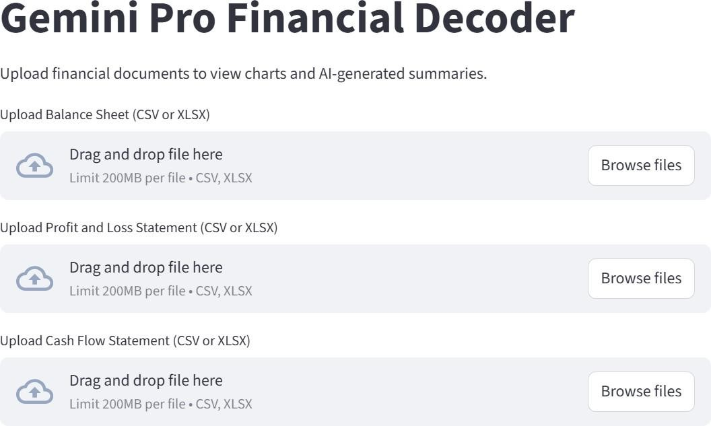

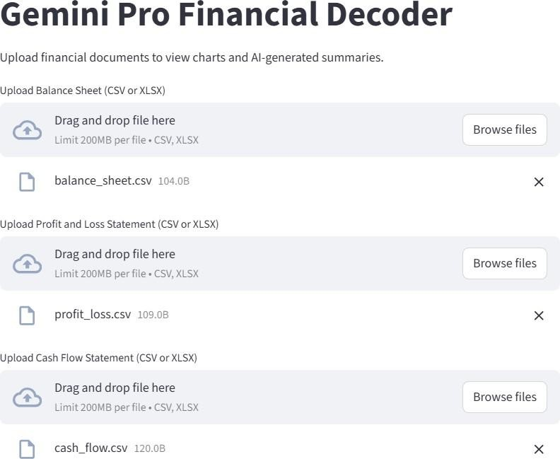

- TESTING

Testing is an essential phase in the development of the Gemini Pro Financial Decoder to ensure that the system functions correctly, performs efficiently, and meets user requirements. Various types of testing were conducted to validate system reliability, accuracy, and security.

Functional Testing
Functional testing was performed to verify that all system features work as expected. Tested Functionalities:
  - User registration and login
  - Uploading financial documents (PDF, Excel, CSV)
  - Data preprocessing and validation
  - AI-based financial analysis
  - Insight generation and visualization
  - Report download functionality

Performance Testing
Performance testing was conducted to evaluate system responsiveness and stability under different loads.
Parameters Evaluated:
  - Response time of AI-generated insights
  - Document processing speed
  - Handling multiple user requests
  - System stability during batch uploads

Security Testing
Security testing ensured protection of sensitive financial data. Security Checks Included:
  - Authentication and authorization validation
  - Token verification (JWT)
  - Secure data transmission using HTTPS
  - Prevention of unauthorized access

Usability Testing
Usability testing was conducted to ensure the interface is user-friendly and intuitive. Feedback was collected to improve navigation, clarity of insights, and dashboard design.

SCREENSHOTS

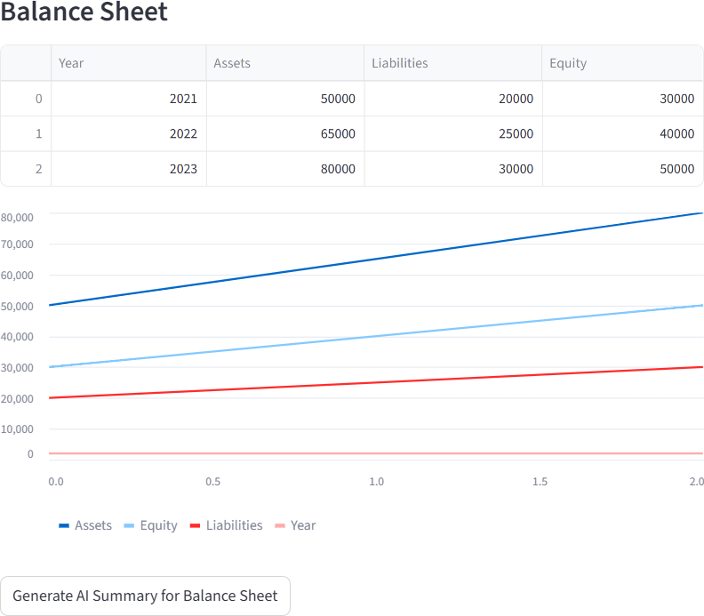

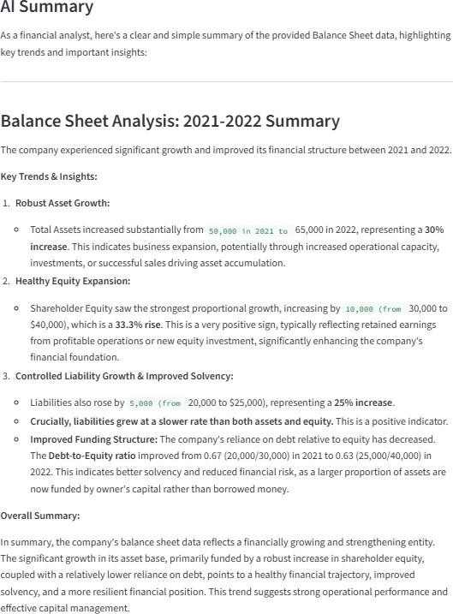

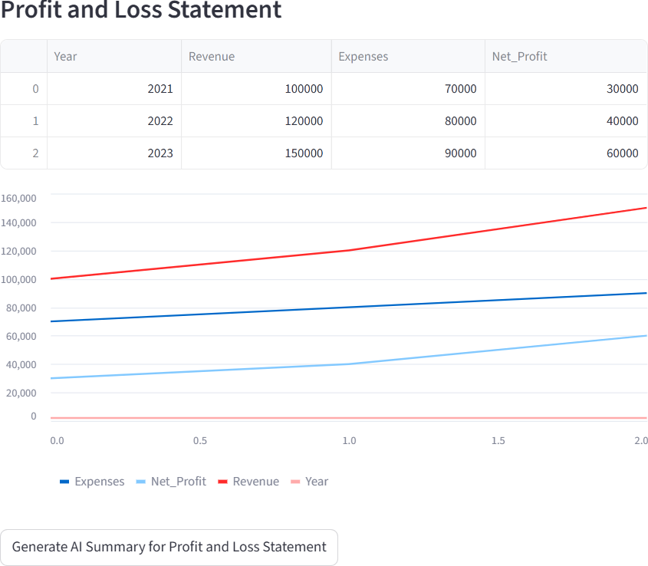

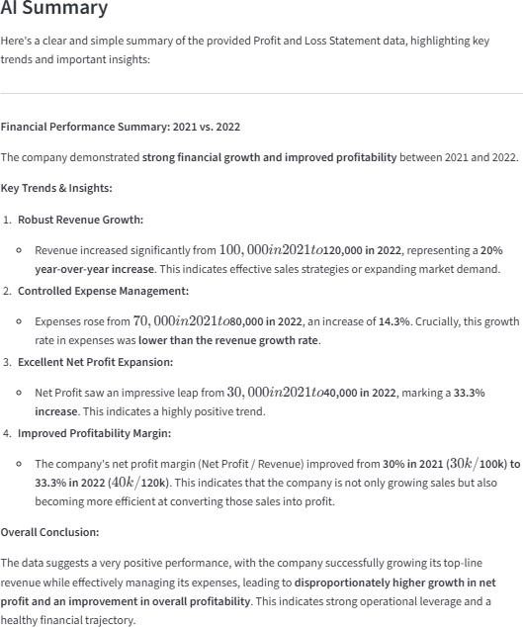

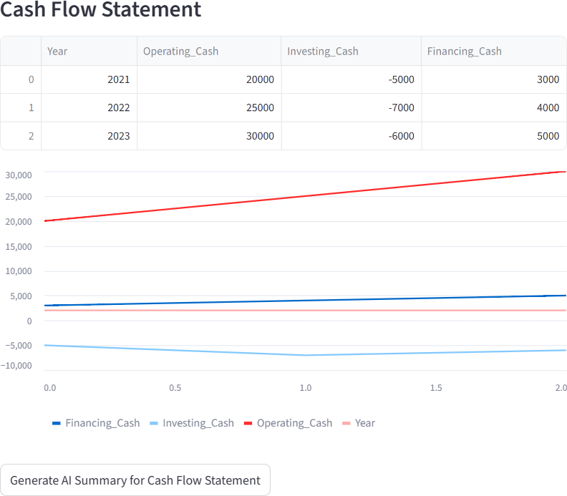

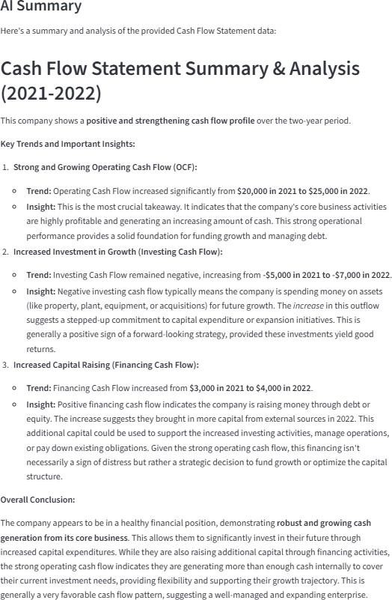

- KNOWN ISSUES
Although the Gemini Pro Financial Decoder performs efficiently, certain limitations and known issues were identified during development and testing.

Dependency on API Availability
The system relies on the Gemini Pro API for financial analysis. If the API service is unavailable or experiences latency, insight generation may be delayed.

Large File Processing Delay

Very large financial documents (high-page PDFs or large Excel files) may require additional processing time, affecting response speed.

Data Formatting Variability
Financial documents with inconsistent formatting, missing values, or non-standard structures may impact preprocessing accuracy.

Limited Context Understanding

In highly complex financial scenarios, AI-generated insights may require expert validation for complete reliability.

Internet Requirement

Since the system uses cloud-based AI services, a stable internet connection is necessary for proper functioning.

Scalability Under Heavy Load

Under very high concurrent user traffic, system performance may decrease unless additional cloud scaling is implemented.

FUTURE ENHANCEMENT
The Gemini Pro Financial Decoder has strong potential for further improvements and expansion. Future enhancements can make the system more intelligent, scalable, and user- friendly.

Real-Time Financial Data Integration
The system can be enhanced to integrate real-time stock market data, banking APIs, and accounting software to provide live financial analysis and updates.

Predictive Analytics & Forecasting
Advanced machine learning models can be incorporated to predict future financial trends, revenue growth, risk probability, and investment performance.

Multi-Language Support
Adding support for multiple languages will make the platform accessible to users from

different regions.

Explainable AI (XAI)
Implementing explainable AI techniques can help users understand how insights and recommendations are generated, increasing transparency and trust.

Mobile Application Development
Developing a mobile application will improve accessibility and allow users to analyze financial data on the go.

Advanced Risk & Fraud Detection
The system can be enhanced with anomaly detection and fraud analysis models for deeper financial risk assessment.

Cloud Deployment & Scalability
Future upgrades can include full cloud deployment with containerization (Docker/Kubernetes) to support large-scale enterprise usage.

